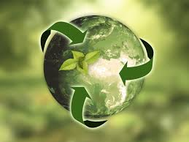 SOLAR POTENTIAL

How India will become a global power by using its solar potential?OBJECTIVE: USING VISUALIZING TOOL TO SHOWCASE THE SOLAR POTENTIAL

* CURRENT POTENTIAL OF INDIA:

*India has a large solar energy potential, with the National Institute of Solar Energy (NISE) estimating it to be around 748 gigawatts. As of August 31, 2024, India's total solar capacity was 90.76 GW AC*

* TARGET: *500 GW of renewable energy installed capacity by 2030.*

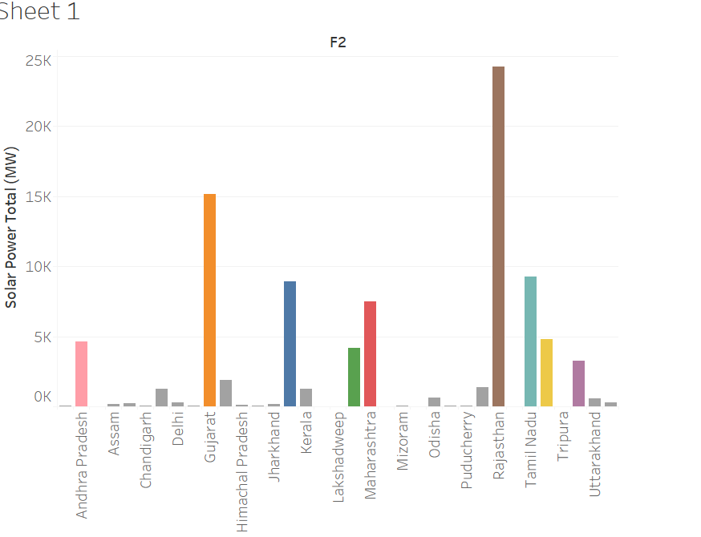

***India is the world's third largest producer of renewable energy****, with*[*40% of its installed electricity capacity*](https://pib.gov.in/PressReleaseIframePage.aspx?PRID=1785808)*coming from non-fossil fuel sources*

***GLOBAL APPROACH:***

* ***OSOWOG INITIATIVE: “the sun never sets”***

*In October 2018, Prime Minister Narendra Modi proposed the idea of One Sun, One World, One Grid (OSOWOG) for the first time at the First Assembly of the International Solar Alliance (ISA). During COP26 in November 2021, the Green Grids Initiative (GGI) was launched by the United Kingdom (UK) as a key enabler of net zero in India’s and the UK’s shared vision of 2030****.***

* ***INTERNATIONAL SOLAR ALLIANCE “Making solar a preferred choice of energy”***
* ***HEADQUARTER IS LOCATED IN GURUGRAM, HARYANA, INDIA***



*The Inter-governmental treaty-based international organization. United Nations Observer Status. Global mandate to catalase global solar growth by helping to reduce the cost of financing and technology for solar 114 Signatories including 92 Member Countries Universal and Affordable last-mile electricity connectivity towards facilitating economic development and environmental impact*

***Contributors: Countries lies in the TROPIC OF CANCER (23°30′ N) and TROPIC OF CAPRICON (23°30′ S) OF THE EARTH’S HEMISPHERE.***

***3 PHASES OF OSOWOG INITIATIVE***



|  |  |
| --- | --- |
| **PHASE-1** | *The Indian grid would be connected to the grids of the Middle East, South Asia, and South-East Asia to develop a common grid.* |
| **PHASE-2** | *Renewable resources in Africa.* |
| **PHASE-3** | *The third phase would look at achieving true global interconnection with the aim of 2,600 GW of interconnection by 2050. The goal is to integrate as many countries as possible to create a single power grid of renewable energy. This can then be accessed by all countries.* |

**Conclusion:**

Country level:

*As energy demand rises with the growing population, it is essential to meet domestic needs. This can be achieved by transitioning from conventional to non-conventional energy sources.*

International level:

*Although ISA and OSOWOG are collective approaches with the clear intention of sustainability, minimizing conventional fuel sources and promoting renewable energy, international dependencies on conventional sources will decrease, and global dependencies on renewable energy will increase. This positions India to become a world leader in solar energy.*